[](http://www.calstatela.edu/centers/hipic) CIS5560 Term Project Tutorial

#### Authors: Jay Joshi;Shradha Shinde; Sowmya Mareedu

#### Instructor: [Jongwook Woo](https://www.linkedin.com/in/jongwook-woo-7081a85)

#### Date: 05/17/2020

**Lab Tutorial**

Jay Joshi [(jjoshi6@calstatela.edu)](mailto:jjoshi6@calstatela.edu)

Shradha Shinde [(sshinde6@calstatela.edu)](mailto:sshinde6@calstatela.edu)

Sowmya Mareedu [(smareed@calstatela.edu)](mailto:smareed@calstatela.edu)

05/17/2019

**Applications of Machine Learning Models for Amazon Product Review Data**

**Objectives**

**List what your objectives are.** In this hands-on lab, you will learn how to implement the following machine learning algorithms:

* Arima Seasonal
* Arima Non Seasonal
* Average Seasonal ETS and Arima
* ETS Seasonal
* ETS Non Seasonal

**Platform Specification**

* Microsoft Azure Machine Learning Studio
* # of nodes: 1
* Total Memory Size: 10 GB

**Steps to create an experiment using ML studio:**

1. Data Preparation
2. Train the model
3. Evaluating the model

**Timeseries Prediction**

1. **Data Preparation**
2. Open a browser and browse to [https://studio.azureml.net.](https://studio.azureml.net/) Then sign in using the Microsoft account associated with your Azure ML account.
3. Create a new blank experiment and give it the title **Time Series Forecasting**.
4. Upload the LAcases*.csv* file and drag it to canvas
5. Search for the **Edit Metadata (Metadata Editor)** module and drag it onto the canvas.
6. Connect the output of the ***Time Series Dataset*** dataset to the **Dataset** input of the **Edit Metadata (Metadata Editor)**.
7. Configure the properties of the **Edit Metadata (Metadata Editor)** to rename the Column from N1725 to data:
   * **Launch Column selector** and select the column: N1725
   * **Categorical**: Unchanged
   * **Fields**: Unchanged
   * **New column names**: data
8. Search for the **Split Data** module and drag it onto the canvas. Select “Relative Expression” and in Relational Expression give the value as “\"time" <= 108”
9. Connect the **Results dataset** output of the **Edit Metadata** module to the **Dataset input** of the **Split Data** module.
10. **Train the Model**

**Arima Seasonal**

1. Select the Execute R script Module and Name it as “Arima Seasonal”. Insert the below code snippet to pass the data frame to train to Arima Seasonal:

Save and run the experiment, we will get below results:

1. Connect the **Split data’s 1st** module’s output of the to the input of the **Execute R script** first an**d Split Data’s** 2nd output module to the **Execute R script** second’s inputmodule.
2. Drag the Edit Metadata module and connect the output of **Execute R script** to input of **Edit Metadata** module. Configure the properties of the **Edit Metadata** module as follows:
   * **Launch Column selector** and select the column: forecast
   * **Categorical**: Unchanged
   * **Fields**: Unchanged
   * **New column names**: seasonal_arima

1. Add **Join Data** Module. Connect the 1st output of **Execute R script** module to 2nd input port of **Join Data** module and **Split Dat**a’s 2nd output port to 1st input of **Join Data** input port.
2. Drag the Execute R script module and connect output of the Join Data’s Input Module.
3. Add the code to Execute R Script Module.

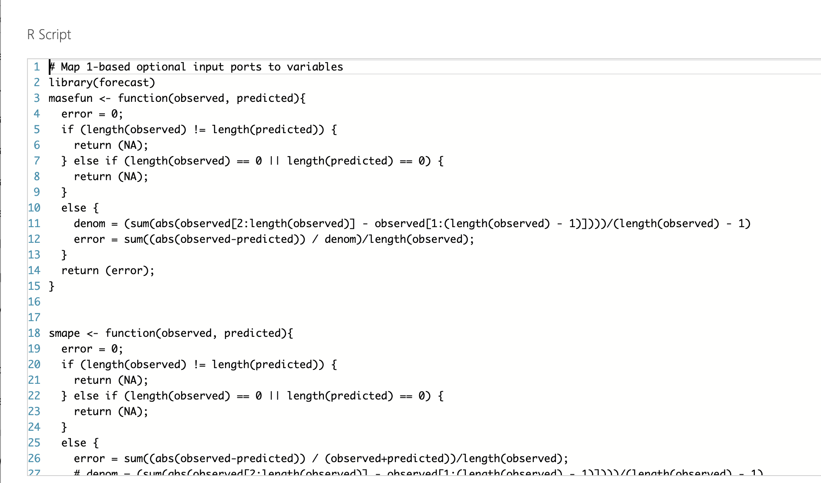

1. Visualize the R results of the Execute R script module by selecting “R Device” =>   
   Visualize”.
2. Save and run the experiment.
3. We will get below results.

**Arima Non Seasonal**

1. Select the Execute R script Module and Name it as “Arima Non Seasonal”. Insert the below code snippet to pass the data frame to train to Arima Seasonal:

Save and run the experiment, we will get below results:

1. Connect the **Split data’s 1st** module’s output of the to the input of the **Execute R script** first an**d Split Data’s** 2nd output module to the **Execute R script** second’s inputmodule.
2. Drag the Edit Metadata module and connect the output of **Execute R script** to input of **Edit Metadata** module. Configure the properties of the **Edit Metadata** module as follows:
   * **Launch Column selector** and select the column: forecast
   * **Categorical**: Unchanged
   * **Fields**: Unchanged
   * **New column names**: non_seasonal_arima

1. Add **Join Data** Module. Connect the 1st output of **Execute R script** module to 2nd input port of **Join Data** module and **Split Dat**a’s 2nd output port to 1st input of **Join Data** input port.
2. Drag the Execute R script module and connect output of the Join Data’s Input Module.
3. Add the code to Execute R Script Module.

1. Visualize the R results of the Execute R script module by selecting “R Device” =>   
   Visualize”.
2. Save and run the experiment.
3. We will get below results.

**Average Seasonal ETS and Arima Forecast**

1. Select the Execute R script Module and Name it as “Arima Non Seasonal”. Insert the below code snippet to pass the data frame to train to Arima Seasonal:

Save and run the experiment, we will get below results:

1. Connect the **Split data’s 1st** module’s output of the to the input of the **Execute R script** first an**d Split Data’s** 2nd output module to the **Execute R script** second’s inputmodule.
2. Drag the Edit Metadata module and connect the output of **Execute R script** to input of **Edit Metadata** module. Configure the properties of the **Edit Metadata** module as follows:
   * **Launch Column selector** and select the column: forecast
   * **Categorical**: Unchanged
   * **Fields**: Unchanged
   * **New column names**: average_seasonal Ets

1. Add **Join Data** Module. Connect the 1st output of **Execute R script** module to 2nd input port of **Join Data** module and **Split Dat**a’s 2nd output port to 1st input of **Join Data** input port.
2. Drag the Execute R script module and connect output of the Join Data’s Input Module.
3. Add the code to Execute R Script Module.

1. Visualize the R results of the Execute R script module by selecting “R Device” =>   
   Visualize”.
2. Save and run the experiment.
3. We will get below results.

**ETS Seasonal**

1. Select the Execute R script Module and Name it as “Arima Non Seasonal”. Insert the below code snippet to pass the data frame to train to Arima Seasonal:

Save and run the experiment, we will get below results:

1. Connect the **Split data’s 1st** module’s output of the to the input of the **Execute R script** first an**d Split Data’s** 2nd output module to the **Execute R script** second’s inputmodule.
2. Drag the Edit Metadata module and connect the output of **Execute R script** to input of **Edit Metadata** module. Configure the properties of the **Edit Metadata** module as follows:
   * **Launch Column selector** and select the column: forecast
   * **Categorical**: Unchanged
   * **Fields**: Unchanged
   * **New column names**: sesonal_ets

1. Add **Join Data** Module. Connect the 1st output of **Execute R script** module to 2nd input port of **Join Data** module and **Split Dat**a’s 2nd output port to 1st input of **Join Data** input port.
2. Drag the Execute R script module and connect output of the Join Data’s Input Module.
3. Add the code to Execute R Script Module.

1. Visualize the R results of the Execute R script module by selecting “R Device” =>   
   Visualize”.
2. Save and run the experiment.
3. We will get below results.

**ETS Non Seasonal**

1. Select the Execute R script Module and Name it as “Arima Non Seasonal”. Insert the below code snippet to pass the data frame to train to Arima Seasonal:

Save and run the experiment, we will get below results:

1. Connect the **Split data’s 1st** module’s output of the to the input of the **Execute R script** first an**d Split Data’s** 2nd output module to the **Execute R script** second’s inputmodule.
2. Drag the Edit Metadata module and connect the output of **Execute R script** to input of **Edit Metadata** module. Configure the properties of the **Edit Metadata** module as follows:
   * **Launch Column selector** and select the column: forecast
   * **Categorical**: Unchanged
   * **Fields**: Unchanged
   * **New column names**: non_sesonal_ets

1. Add **Join Data** Module. Connect the 1st output of **Execute R script** module to 2nd input port of **Join Data** module and **Split Dat**a’s 2nd output port to 1st input of **Join Data** input port.
2. Drag the Execute R script module and connect output of the Join Data’s Input Module.
3. Add the code to Execute R Script Module.

1. Visualize the R results of the Execute R script module by selecting “R Device” =>   
   Visualize”.
2. Save and run the experiment.
3. We will get below results.

**References**

1. URLs of Data Source: <https://github.com/datasets/covid-19>
2. URL of our Github: <https://github.com/shradha5410/5560>
3. URL of References :  <https://gallery.azure.ai/Experiment/Time-Series-Forecasting-8>